4th Quarterly Newsletter: April-June
Ms. Hill’s 6th Grade ELA

Important Dates

April 27
Book Project Due

May 11
M&Ms ONLY: Call to Action Project Due

May 14
STAAR Math Test

May 15
STAAR Reading Test

khill@cedars-academy.org
mshillela.weebly.com

Weekly Routine
STAAR Tests
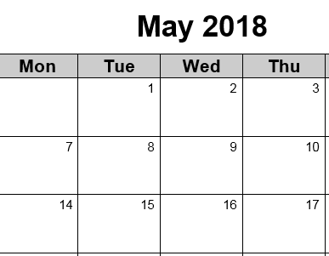

4th Quarter Syllabus
Essential Questions: How do we support conclusions on theme and main idea with text evidence? How can language be used to draw connections across times and cultures?
How can we address our personal responsibility in the world? What is a “call to action”? What makes a “call to action” persuasive?
 | Type/Title | Formative Assessments | Summative Assessments
Independent Reading | Student Choice of Genre (chapter book) | -Friday Reflections | Student Choice of Sandwich, Jacket or Scrapbook
Independent Writing | Reader Response | -26 Lines due most Fridays | Portfolio Assessment
Vocabulary | Embedded | Embedded | STAAR
M&Ms ONLY: Kindness Call to Action | SCOPE: “Escape from Slavery” and Harriet Tubman’s Legacy | -Reader Response  -LAND & PIEs  -Graphic Organizers | M&Ms ONLY: Legacy  “Call to Action” Project

