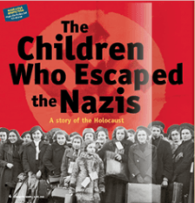Paired Presentation: Holocaust to Today: Call to Action
due Friday 5/11

The goal is to present your pair’s response to a theme across multiple genres (Holocaust literature in SCOPE, Night excerpt, and the current event article of your choice) and conclude with a “call to action”. The following essential questions should be explored:
- How do we determine author’s purpose?
- How do we draw thematic conclusions?
- How can we address our personal responsibility to reduce/eliminate hate in the world?
- What is a “call to action”? What makes a “call to action” persuasive?

Formative Assessments:

- SCOPE in-class assignments
- Current Event PIE Homework due Friday 4/20

Summative Assessment Presentation Requirements (PPT or Prezi must include these 7 slides/information):

- Introduction Slide with your original title and cited images
- PIE on the author’s purpose in SCOPE
- PIE on a universal theme in Night excerpt
- 2 PIEs on current event articles that represents your theme in our world today (one from each student)
- Determine a “call to action” to address personal responsibility on eliminating/reducing hate <3
- Works Cited

Completion Requirement: Each student must complete 1 PIE on either SCOPE or Night and 1 PIE on a current event and either the introduction OR call to action slide= 3 slides total. Your final presentation should be emailed to khill@cedars-academy.org by Friday 5/11 and will be graded with the following rubric; presentations may start Wednesday 5/16.

