Middle School ELA Independent Reading
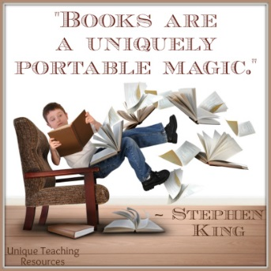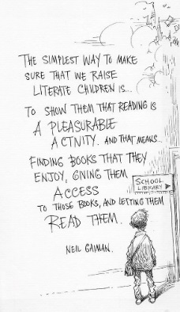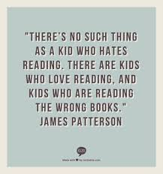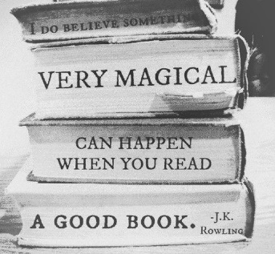
Daily Reading: Sustained Silent Reading in Class
Students will be given time in ELA class every day just to read a book, magazine or comic of their choice. There is no requirement on what kind of book they read or what level they are reading at—just that they spend a sustained amount of time reading silently. We will read the last 20 minutes of class on Monday-Thursday. We will read for 35 minutes in class on every Friday. I will have SCOPE magazines, books, graphic novels, and various comics for students to choose from. Students are also encouraged to bring magazines, books, graphic novels, and various comics from home. Students should also be reading at home! Every day!
Reading Homework: Daily, Weekly, Quarterly
Students will choose and read one “chapter book” in a specific genre every quarter. The book must have multiple chapters and fit into the genre for that quarter. Students should not choose a book they have already read before! They can continue a series of books if it fits our current genre. Always be sure and get the teacher’s approval before you start reading a book. I will have a couple shelves of books in our genre for students to choose from, but students are always encouraged to browse libraries, book stores or find books at home.
This year students will be required to do one Morning Meeting Book Talk on any chapter book of their choice! This will count as a daily “quiz” grade! 7A will meet this requirement 1st quarter.
Every quarter students will complete a “book project” for a major grade. Every quarter the teacher will assign a different project. Basic materials to complete the project are provided in class, but students are encouraged to use creativity! Projects must meet minimum requirements to be accepted and graded. All instructions are provided in class and available online.

6th Grade Reading Homework DUE September 22nd

Students should be reading at home! 1st quarter students may choose any (chapter) book in the “contemporary fiction” or “memoir” genre. “Contemporary fiction” is any book that is a made-up story written by an author alive at the same time that you are alive. A “memoir” is a book that is a true story of someone’s life told like a story. Get approval before you start reading!

Students will also complete an assigned project (see below). For all projects— “one-paragraph” is a minimum of 5 sentences (all projects require 5 paragraphs or 500 words). Reports will be graded with the “Completion Scale” rubric.

Please email Ms. Hill with any questions or concerns. Thank you!
&&&&&&&&&&&&&&&&&&&&&&&&&&&&&&&&&&&&&&&&

Sandwich Book Project due 1st Quarter (9/22)
Here are instructions for creating your sandwich book!
1. Write the book title, author, illustrator (if there is one), and your name the BREAD top.
2. Write a one-paragraph summary of the book on the LETTUCE.
3. Describe or draw the book's setting on the TOMATO.
4. Describe the main character in one-paragraph on the MEAT.
5. Write one-paragraph about a part of the book that made you happy on the CHEESE.
6. Describe a part of the book that you thought was sweet or sad in one-paragraph on the ONION. Also write what you thought of the book.
7. Tell what you liked or didn't like about the author's style in one-paragraph on the BREAD bottom.
*Last put your sandwich together. Fasten it all together with a brad, ring, or staples.

7th Grade Reading Homework DUE September 22nd

Students should be reading at home! 1st quarter students may choose any (chapter) book in the “classic fiction” or “memoir” genre. “Classic fiction” is any book that is a made-up story written by an author that was only alive before you were alive. A “memoir” is a book that is a true story of someone’s life told like a story. Get approval before you start reading!

Students will also complete an assigned project (see below). For all projects— “one-paragraph” is a minimum of 5 sentences (all projects require 5 paragraphs or 500 words). Reports will be graded with the “Completion Scale” rubric.

Please email Ms. Hill with any questions or concerns. Thank you!
&&&&&&&&&&&&&&&&&&&&&&&&&&&&&&&&&&&&&&&&

Sandwich Book Project due 1st Quarter (9/22)
Here are instructions for creating your sandwich book!
1. Write the book title, author, illustrator (if there is one), and your name the BREAD top.
2. Write a one-paragraph summary of the book on the LETTUCE.
3. Describe or draw the book's setting on the TOMATO.
4. Describe the main character in one-paragraph on the MEAT.
5. Write one-paragraph about a part of the book that made you happy on the CHEESE.
6. Describe a part of the book that you thought was sweet or sad in one-paragraph on the ONION. Also write what you thought of the book.
7. Tell what you liked or didn't like about the author's style in one-paragraph on the BREAD bottom.
*Last put your sandwich together. Fasten it all together with a brad, ring, or staples.

