IMPORTANT: REGARDING ELA WRITING ASSIGNMENTS*
- Please understand I will NOT accept a Writing assignment that does not meet the minimum requirements here:
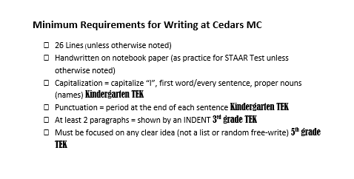
- If a Writing assignment meets minimum requirements, I score it with the appropriate rubric—giving the student feedback.
- If a Writing assignment does not meet minimum requirements--I will pass it back and tell the student “this doesn’t meet the minimum requirements, so you’ll have to finish it/re do it and turn it in late for a 70.”
- Late work is accepted up to one week late for a 70.
- If a student fails to meet minimum requirements before a week late—it will remain a zero in the grade book.
*Student IEPs & 504s will be followed to accommodate these rules

